Page 155
COLLECTION OF SCIENTIFIC ARTICLES OF THE MILITARY ACADEMY OF THE REPUBLIC OF BELARUS 32'2017
153
UDC 519.711.3
APPLICATION OF A SIMULATION SIMULATION SYSTEM
FOR OPTIMIZING SOLUTIONS BASED ON THE ELEMENTS OF THEORY
REFLEXIVE CONTROL
E. V. Rulko;
V.M.Buloychik, Doctor of Technical Sciences, Professor;
A. V. Gertsev, Candidate of Technical Sciences, Associate Professor *
The article describes the mathematical apparatus for assessing the influence of the system of assumptions
commander on the preference for choosing one or another option. In ka-
As a basis for calculations, it is proposed to use an indicator characterizing
the effectiveness of the actions of one side for a given behavior of the other,
obtained as a result of a simulation experiment.
In article the mathematical apparatus of an estimation of influence of the system of assumptions
of the commander on preference of a choice by it of this or that variant of actions is described. As
a basis for calculations it is offered to use the indicator characterizing efficiency of actions of one
party at the set variant of behavior other, received as a result of imitating experiment.
Introduction
The modern approach to combat and combat management requires
knowledge commander of the objective laws of armed struggle and quantitative
justification of his decisions. Moreover, his experience and intuition should be supplemented
mathematical methods, the objectivity of which, multiplied by the possibility
modern mathematical model to predict the course and outcome of hostilities
in accordance with the decision taken, today it becomes necessary in management
troops. It was this that served as the basis for the creation in the Armed Forces of the Republic
Belarus military action simulation system (MIA) designed for
support of decisions made in various levels of military command.
From the point of view of formalizing combat processes, it is currently among the most
complex issues include intellectual support of decisions at the tactical level
management. A lot of research works are being carried out in this direction.
However, their results have not yet received wide practical implementation. it
due to the complexity of the tasks that arise in modern conditions of battle and combat
actions characterized by high maneuverability of forces and assets on the battlefield,
the need for commanders to analyze the current situation in a short time,
planning actions taking into account the uncertainty of a large number of factors.
At the Research Center for Modeling Military Operations (SIC MVD) научно-исследовательском центре моделирования военных действий (НИЦ МВД),
whose task is the development of an internal air system, a number of simulation models have been created for
the tactical level of command and control of the ground forces. They allow you to receive many
indicators and draw conclusions about the quality of various options for organizing the battle and combat
actions and their provision. One of the main requirements implemented in these models is
is their adequate reflection of the most significant aspects of the simulated processes
and connections between them, a fairly detailed account of the terrain, as well as a variety of other
possible conditions. Such models help to anticipate the development of events taking into account
many factors that directly or indirectly affect their course and result.
At the same time, any specific battle is a unique, isolated phenomenon. As in
every single phenomenon is common, inherent in all such processes, and is
special, making this fight different from another. Therefore, on the one hand,
the mathematical model should reflect the most general patterns of the modeled

Page 156
COLLECTION OF SCIENTIFIC ARTICLES OF THE MILITARY ACADEMY OF THE REPUBLIC OF BELARUS 32'2017
154
processes and its capabilities should allow taking into account changes in goals, objectives and conditions
combat operations, on the other hand, with its help it should be possible to
studies of the influence of the characteristics of a specific situation and specific decisions,
taken by the warring parties. The essence of such studies is
in reproducing the commander's reasoning about the degree of influence of various parameters
setting and quantifying this impact. Assuming reasonable behavior
adversary, it is advisable to carry out such reasoning for him and also evaluate their influence.
Thus, the success in organizing a particular battle largely depends on the skill
the commander to try to side with the enemy, to analyze the course of his thoughts,
to understand his possible further actions, to predict their
result and thus be able to act in anticipation, outsmarting it,
to form in him false ideas about the real state of affairs by using
masking (maskirova) or demonstrating false intentions (сформировать у него ложные представления о реальном положении дел путем использования маскировки или демонстрирования ложных намерений [)[1]. In addition, in itself such
a two-way process of analysis can provide additional information for thought
about the best option for their actions in a combat, continuously changing situation.
For a formal description of this type of mental activity of commanders
of the opposing sides, the closest in fact is the apparatus of the theory
reflexive control (hereinafter – TRU) рефлексивного управления (далее – ТРУ).
As a rule, reflexive control means the use of results
imitation of reasoning for the opposing side in the course of making your own decisions
and the impact on the process of making it (the opposing party) decisions by
forming in her the necessary (as a rule, false about us) idea of
setting. The solution obtained in this way can be used for repeated
imitating the reasoning of the enemy, taking into account the fact that this decision to one degree or another
the enemy knows In this regard, the concept of the rank of reflection is introduced. If the decision
is taken without taking into account the opponent's decision, the rank of reflection is zero. If at
making a decision, it is considered that the opponent has a zero rank of reflection and the resulting
under this assumption, the adversary takes the decision into account when planning his actions,
then there is reflection of the first rank, etc. However, it should be noted that
most of the work on TRU primarily on the analysis of controlled processes from the point of view
human psyche [2, 3]. Moreover, some of them are aimed at describing the phenomena
in the field of human relationships and the identification of "internal springs" of a person
by solving the corresponding logical equations. In contrast to this
in [4], the emphasis from the processes of the human psyche is shifted towards discussion
questions of reflective games.
In general, TRU techniques are extensive and cover the scope of creative activity.
human leader. Modeling them in all their diversity essentially consists of a model
lyation of human intelligence. A significant part of the information on this area
concerns the area of ​​junction of the humanities and exact sciences, where the operation is carried out
difficultly formalized concepts.
Formulation of the problem
The beginning of attempts to use TRU in military affairs goes back to the 70s of the XX century [5,
6]. The most prominent military scientists in this field are D. M. Ionov [7],
V. Ye. Yarushek., S. I. Leonenko [8], F. S. Chausov [9] Д. М. Ионов [7],
В. Е. Ярушек., С. И. Леоненко [8], Ф. С. Чаусов [9]. In [10], automation schemes are given
withdrawing a reflexive solution. This publication, according to the authors, is the most
interesting from the point of view of the practical implementation of the elements of TRU. Reflex approach
control, based on the use of a formal language, is described in [11, 12].
Thus, the use of the ideas of reflexive control in the military sphere in the
the present moment is a relevant area that interests many representatives
military applied science. With all this, it should be noted that the described in the above
in publications, the approaches are quite abstract, operate on difficult formalized

Page 157
COLLECTION OF SCIENTIFIC ARTICLES OF THE MILITARY ACADEMY OF THE REPUBLIC OF BELARUS 32'2017
155
concepts (like "Saddam Hussein's model") and do not reflect specific mechanisms
research and modeling of reflexive control on a computer [10].
The most important point in modern TRU is the fact that in real life
in conditions of armed confrontation, any assumptions by the commander regarding
the opponent's judgments or his awareness will not have an unambiguous (point)
character. The commander cannot say for sure what his adversary knows or that
the enemy assumes the relative knowledge of the commander. Intelligence data
are often incomplete, and sometimes can be deliberately distorted
the opposing side, that is, to be disinformation. Moreover, the subject is definitely not
knows how the enemy will behave. He can only assume this with a certain amount.
probabilities based on personal experience and experience in studying the enemy. Data
assumptions are multiple. Therefore, the commander usually operates with a certain
a system of options (when planning an operation, military action, battle). Often it
assumptions relate specifically to how the enemy will act or what
he will choose the disposition of forces.
In game theory, a variant of behavior or a set of decision rules
called a strategy (or doctrine). Moreover, if we compare this with a game of chess, where
the moves of each side can be calculated (there are many of them, but of course) and the sides
they are seen, then in conditions of an armed struggle, awareness is significantly lower and
There can be an infinite number of such options. This is a consequence of the
that opponents are actively using camouflage, deceptive maneuvers and other kinds
disinformation in order to conceal their true intentions and the real state of affairs in
battlefield.
With regard to the military sphere, various options for the actions of the parties, the main
scenarios which are reflected in the mind of the commander are displayed on his working map
(picture 1).

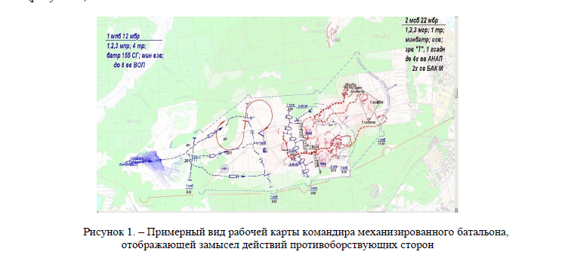

Figure 1. - An approximate view of the working card of the commander of a mechanized battalion,
reflecting the plan of actions of the warring parties
In the modeling system (SM) developed at the Research Center of the Ministry of Internal Affairs (НИЦ МВД системе моделирования (СМ) стратегии задаются), strategies are set
using a special visual constructor by forming
appropriate control algorithms for each side. They define
the spatio-temporal order of action of units, specific boundaries, sectors
and other initial data, as well as the system of major events and the order of reaction to them.
As noted above, the parties' awareness of each other affects
the decision to be taken. So, if we know, for example, based on intelligence data,
that the enemy will most likely use some strategy A , then

Page 158
COLLECTION OF SCIENTIFIC ARTICLES OF THE MILITARY ACADEMY OF THE REPUBLIC OF BELARUS 32'2017
156
in this case, it is logical for us to use a strategy B that would maximize
our objective function (gain) for the chosen strategy A of the adversary (and, as a rule,
would minimize the opponent's gain). However, what we believe about
what the adversary knows about our behavior will probably also influence the accepted
us a solution. Such reasoning can be extended further, to higher
ranks of reflection. In this regard, the first task requiring its resolution within the framework of
the application of elements of TRU to military control is the development of an assessment mechanism
influence of awareness of the parties on their decisions.
The solution of the problem
Let us consider how the created SM allows solving this problem for a mechanized
battalion of ground forces.
Making a decision in difficult, responsible situations, the commander carries out
the process of mentally modeling the results of a particular behavior scenario
and developments. Moreover, the effectiveness of his solution depends on the actions of the opponent -
enemy. Therefore, the prescribed behavior of the opponent has
influence on the choice of their own behavior.
If, when making our decision, we cannot assume a possible option
the behavior of the enemy (there is no information about the enemy), then it is accepted
consider that our solution was obtained taking into account the zero rank of reflection. In formal
representation, this corresponds to the equally preferable choice of one of the admissible
options for decisions, alternatives of behavior.
If, when making our decision, we believe that the enemy has a zero rank
reflection and we take this into account (i.e., using the SM, we choose the best
own version of actions), then our solution has already been obtained taking into account the first rank of reflection.
If, when making our decision, we believe that the enemy, choosing his option
behavior, takes into account the nature of his intended actions on our part,
then our solution has already been obtained taking into account the second rank of reflection. In these conditions, we
making a decision, as it were, we take the side of the enemy, trying to find out what
know about us, use modeling to evaluate the effectiveness of its options
actions and make the best decision for him, and then, taking into account this information,
choose our own behavior.
In theory, this process can be continued. But the common thing here is that
information regarding behaviors at each of the higher ranks
reflexive control, affects the choice of options at a lower rank.
Therefore, the problem of determining the influence of awareness on the preference
the choice of one or another option of behavior turns into the task of determining the influence
distribution of the preference for the choice of behaviors in the higher ranks on
such a distribution in the lower ranks.
From this follows a quite obvious conclusion that by managing intelligence processes
and protection of information (extraction of someone else's or hiding their information) and the process
disinformation of the enemy, we can influence the decisions he makes. However, until now
since then there was no possibility of a quantitative assessment of the effectiveness of such an influence,
which is essentially the basis for the reflexive control of the enemy.
In this sense, the application of the SM developed by us is of interest.
In [4], it is shown that the maximum appropriate rank of the reflexive
management, which today should be considered when making decisions, is equal to two. When
the chain of reflexive reasoning that needs to be reproduced looks like:
“Determine what the enemy thinks about my behavior, based on this make a decision
for him, then on the basis of the information received to make his own decision. "
Quantitative accounting for higher ranks of reflection is a formalization
"Significant tricks" [1]. He is fraught with the danger of "outsmarting himself"

Page 159
COLLECTION OF SCIENTIFIC ARTICLES OF THE MILITARY ACADEMY OF THE REPUBLIC OF BELARUS 32'2017
157
and today it is difficult to implement, since it will require much more complex and accurate
predictive models of simulated processes and highly adequate models
"Intellectual abilities" of specific decision-makers (commanders
warring parties). And there are no such models yet. Moreover, on
tactical level of decision-making, as a rule, there is no information on the counter
standing commander, necessary for modeling his mental activity.
In this sense, it should be noted that in [10] an example of constructing a model
behavior of Saddam Hussein, obtained from the results of many years of observation.
The use of such a model made it possible to quickly achieve success in the operation.
Consider an example of choosing behavior alternatives by Red and Blue using
simulation of the process of their confrontation on the developed SM.
Let, according to the results of battle planning, the Reds (we) have three ( n = 3)
behavioral alternatives given in the form of appropriate behavior strategies
(Table 1). The Reds also have some information about the BLU (enemy) and non-
which probability can suggest their possible steps in the form of four alternatives
( m = 4). In this case, these are alternatives, figuratively speaking, a phantom agent,
existing in the minds of the Reds. It is obvious that the degree of their identity with the real
behavior is determined by the degree to which the Reds are aware of their opponent.
Blue, with some information about Red, will also build a system
assumptions about their behavior and choose their strategy under the influence of
how the Reds will act from their point of view. Let the possible construction options

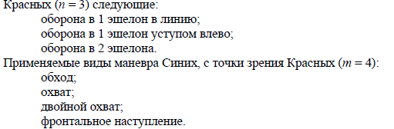
The red ones ( n = 3) are as follows:
defense in 1 echelon in line;
defense in 1 echelon with a ledge to the left;
defense in 2 echelons.
Applicable types of BLU maneuver, from the point of view of Red ( m = 4):
bypass;
coverage;
double coverage;
frontal offensive.
It is obvious that each of the possible alternatives of the parties corresponds to a certain
preference - the probability of its choice (choice of a given scenario of the development of events).
Let's introduce the notation:
is the preference of the j -th option of actions of the side x in relation to the
rone y at the i -th rank of reflexive control.
For our example, you can write:
the preference of the j -th, j = 1, 2, 3, option for Red's actions
with respect to blue at the zero rank of reflexive control (when, as a rule,

the alternatives are equally likely); preference of the j -th, j = 1, 2, 3, 4, option of BLU's actions (phantom
agent) in relation to Reds at the first rank of reflexive control, etc.

For a specific solution of one side with the chosen option behavior, another simulation system allows you to obtain values
selected indicators of the effectiveness of each side of its combat mission: losses at a given moment in time, the line reached by one of the parties at that moment time, time of holding the boundary, etc. Given that there can be many such possible behaviors, for their comparative assessment, we introduce an indicator characterizing the effectiveness of actions one side for a given variant of behavior of the other ρ x ∈ [−1; 1] and obtained by simulation results. Here, the index x defines the affiliation of the party, relative to which the indicator is calculated: ρ С for the Blue side and ρ К - for the Red ones.

Page 160
COLLECTION OF SCIENTIFIC ARTICLES OF THE MILITARY ACADEMY OF THE REPUBLIC OF BELARUS 32'2017
158
Moreover, their extreme values ​​−1 and 1 correspond to the least and most favorable outcomes.
The expression for calculating the value of the exponent ρ x is synthesized depending on combat missions of the parties. In this case, from the normalized value characterizing the failure actions to carry out a combat mission by the enemy, the normalized
a value that characterizes the success of actions to fulfill their combat mission. When obvious assumption about the desire of the opposing sides to maximize success, an increase in this difference will contribute to the choice of the best option for their action.

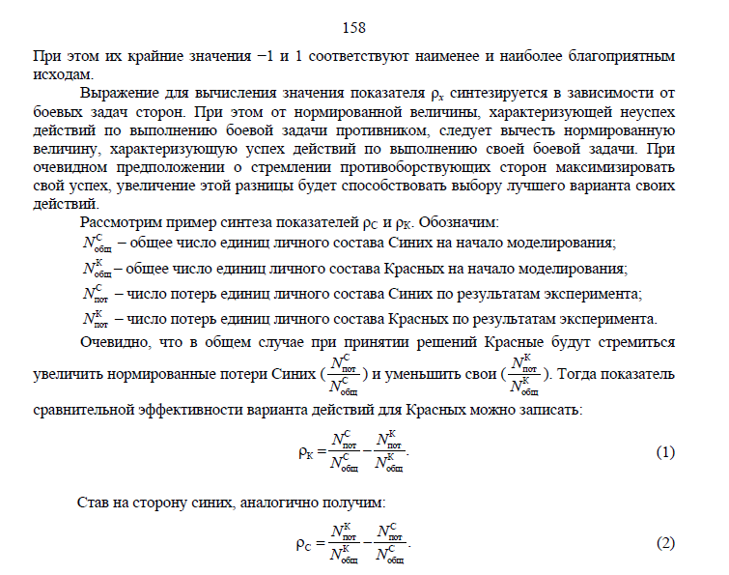
Consider the following example of synthesis parameters ρ C and ρ K . We denote:
FROM
total
N - the total number of BLU personnel at the start of the simulation;
TO
total
N is the total number of Red personnel at the start of the simulation;
FROM
sweat
N is the number of BLU personnel losses based on the experiment results;
TO
sweat
N is the number of losses of Red personnel units according to the results of the experiment.
Obviously, in the general case, when making decisions, the Reds will tend to
increase BLU's normalized losses (
FROM
sweat
FROM
total
N
N
) and reduce your (
TO
sweat
TO
total
N
N
).

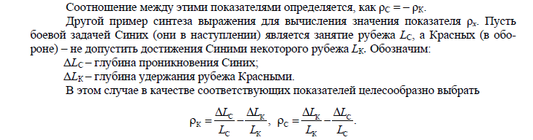

Then the indicator
the comparative effectiveness of a Red line of action can be written:
FROM
TO
sweat
sweat
TO
FROM
TO
total
total
...
N
N
N
N
ρ =
-
Becoming on the side of the blue, we will similarly get:
TO
FROM
sweat
sweat
FROM
TO
FROM
total
total
...
N
N
N
N
ρ =
-
The relationship between these parameters is determined as ρ C = - ρ K .
Another example of synthesizing an expression for calculating the value of the exponent ρ x . Let be
the combat mission of the BLUs (they are on the offensive) is to occupy the L C line , and the Reds (in both
Rhône) - to prevent the achievement of a milestone Blue L K . We denote:
Δ L С - depth of penetration of Blue;
Δ L K - the depth of holding the line by the Reds.
In this case, it is advisable to choose
FROM
TO
TO
FROM
TO
,
L
L
L
L
∆
∆
ρ =
-
FROM
TO
FROM
TO
FROM
...
L
L
L
L
∆
∆
ρ =
-
Similar reasoning can be carried out for various types of combat missions,
solved by each of the parties, and subsequently reproducible and estimated with the help of
CM.
Let for the first example, when the parties seek to inflict each other
maximum damage, possible options for Red's actions and possible options
BLU's actions, from RED's point of view, and their preference is represented by
in tables 1 and 2.
(1)
(2)

Page 161
COLLECTION OF SCIENTIFIC ARTICLES OF THE MILITARY ACADEMY OF THE REPUBLIC OF BELARUS 32'2017
159

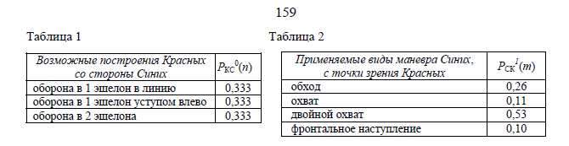

Table 1
table 2
Let us carry out Krasnykh's reasoning for the first rank of reflexive decision making.
We take the side of the BLU. We believe that they know nothing about the Reds, i.e.
consider three (in the general case, there may be much more) equally probable
variants of our behavior, which corresponds to the absence of any information about their
preference (table 1). We assume that Blue for their four variants
actions with the help of SM received assessments of their effectiveness and determined their
deference (table 2). In the general case, such options can also be significantly
more, but from all of them the unlikely and least effective are cut off and
the best.
Then for the first ( i = 1) alternative of BLU's behavior (maneuver "bypass") using
SM and expressions (1), estimates of the indicator of comparative efficiency were obtained,
given in the column ρ K (1 , n ) (Figure 2).

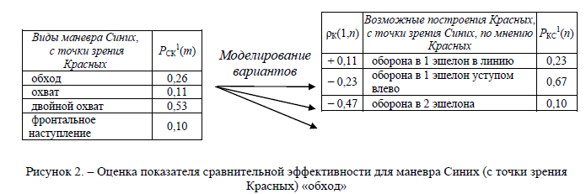

Figure 2. - Assessment of the indicator of comparative efficiency for the BLU maneuver (in terms of
Red) "bypass"
From the figures it follows that for the Reds, only the defense of 1 echelon in the line leads
to success (ρ K (1,1) = + 0.11). All other options are negative.
indicator of comparative efficiency (ρ K (1,2) <0 and ρ K (1,3) <0). To maneuver BLU
"Coverage" ( i = 2) the calculated values ​​of the indicator ρ K (2, n ) look as follows
(Figure 3).

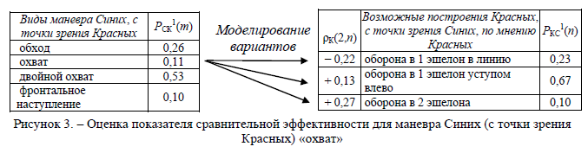

Figure 3. - Assessment of the indicator of comparative effectiveness for the BLU maneuver (in terms of
Red) "coverage"
It follows from the figures that when the phantom agent (Blue) performs the maneuver
"Coverage" of the Reds' defense in 2 echelons leads to the greatest success (ρ K (2.3) = + 0.27).
Similarly, for all other BLU alternatives, the values ​​of the indicator
comparative effectiveness (Figures 4 and 5).
Possible Red Formations
from the BLU side
P KS
0 ( n )
defense in 1 echelon in line
0.333
defense in 1 echelon stepped to the left 0.333
defense in 2 echelons
0.333
Applicable types of BLU maneuver ,
from the point of view of the Reds
P CK
1 ( m )
detour
0.26
coverage
0.11
double coverage
0.53
frontal attack
0.10
ρ K (1, n )
Possible RED formations ,
from BLU's point of view , according to
Red
P KS
1 ( n )
+ 0.11 defense in 1 echelon in line
0.23
- 0.23
1 echelon ledge defense
to the left
0.67
- 0.47 defense in 2 echelons
0.10
BLU maneuver types ,
from point of view
Red
P CK
1 ( m )
detour
0.26
coverage
0.11
double coverage
0.53
frontal
offensive
0.10
BLUE maneuver types , s
the Reds' point of view
P CK
1 ( m )
detour
0.26
coverage
0.11
double coverage
0.53
frontal
offensive
0.10
ρ K (2, n )
Possible RED formations ,
from BLU's point of view , according to
Red
P KS
1 ( n )
- 0.22 defense in 1 echelon in line
0.23
+ 0.13
1 echelon ledge defense
to the left
0.67
+ 0.27 defense in 2 echelons
0.10
Modeling
options
Modeling
options

Page 162
COLLECTION OF SCIENTIFIC ARTICLES OF THE MILITARY ACADEMY OF THE REPUBLIC OF BELARUS 32'2017
160

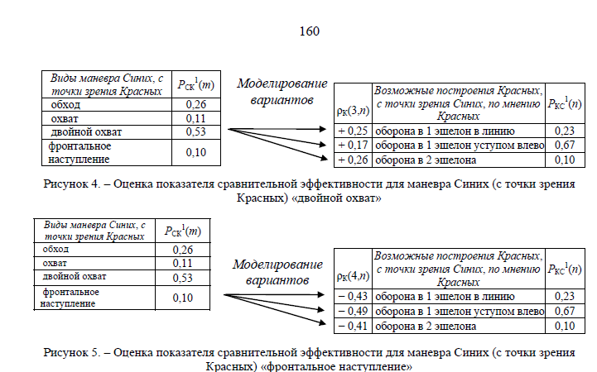

Figure 4. - Assessment of the indicator of comparative effectiveness for the BLU maneuver (in terms of
Red) "double coverage"
Figure 5. - Assessment of the indicator of comparative effectiveness for the BLU maneuver (in terms of
Red) "frontal offensive"
To compare the preference of the options for the action of phantom BLU
in relation to the Reds, we introduce the indicator K
i
beta , which characterizes the average expected success
BLUE for the i- th behavior of RED. So, if the phantom makes a decision on
Bypass maneuver, BLU's average expected success will matter:

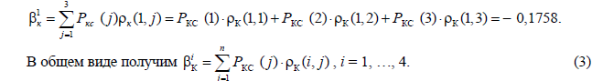

3
1
KS
TO
KS
TO
KS
TO
1
( ) (1, )
(1) (1.1)
(2) (1,2)
(3) (1.3) 0.1758.
to
cop
to
j
R
j
j
R
R
R
=
β =
ρ
=
∙ ρ
+
∙ ρ
+
∙ ρ
= -
∑
In general, we get K
KS
TO
1
() (,)
n
i
j
R
j
ij
=
β =
∙ ρ
∑
, i = 1,…, 4.
BLU's average expected success for all RED behavior alternatives looks like
as follows (table 3).

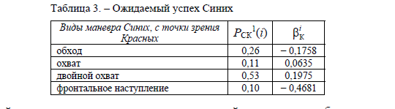

Table 3. - Blue's expected success
The next task is to derive the final probability of choosing a strategy on
based on the initially set probability and the cumulative impact indicator
higher rank. Let j
α is an absolute indicator of the preference for choice
strategy, defined as:


, at
0;
, at
0,
j
j
ij
ij
j
j
ij
j
ij
ij
PP
P
P
⎧
⌈ ⌉
- × β
β <
│
⌊ ⌋
α = ⎨
+ β - × β
β ≥
│⎩
where P j is the value of the probability of the j -th alternative of the i -th rank.
β is the expected success of the current alternative at number j in relation to the alternative
nativs of the higher i- rank, determined in accordance with (3).
BLUE maneuver types , s
the Reds' point of view
P CK
1 ( m )
detour
0.26
coverage
0.11
double coverage
0.53
frontal
offensive
0.10
ρ K (3, n )
Possible RED formations ,
from BLU's point of view , according to
Red
P KS
1 ( n )
+ 0.25 defense per echelon per line
0.23
+ 0.17 defense per echelon with a ledge to the left 0.67
+ 0.26 defense in 2 echelons
0.10
BLUE maneuver types , s
the Reds' point of view
P CK
1 ( m )
detour
0.26
coverage
0.11
double coverage
0.53
frontal
offensive
0.10
ρ K (4, n )
Possible RED formations ,
from BLU's point of view , according to
Red
P KS
1 ( n )
- 0.43 defense in 1 echelon in line
0.23
- 0.49 defense in 1 echelon with a ledge to the left 0.67
- 0.41 defense in 2 echelons
0.10
BLU maneuver types , from the point of view
Red
P CK
1 ( i )
TO
i
β
detour
0.26
- 0.1758
coverage
0.11
0.0635
double coverage
0.53
0.1975
frontal attack
0.10
- 0.4681
(4)
Modeling
options
Modeling
options
(3)

Page 163
COLLECTION OF SCIENTIFIC ARTICLES OF THE MILITARY ACADEMY OF THE REPUBLIC OF BELARUS 32'2017
161

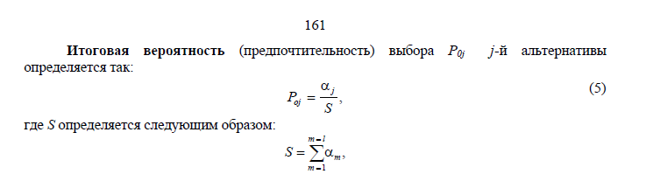

The final probability (preference) of the choice of P 0j j -th alternative
defined like this:
, j
oj
P
S
α
=
where S is defined as follows:
1
,
ml
m
m
S
=
=
=
α
∑
where l is the total number of alternatives of the corresponding rank, in this case, the first.
In our case, the RED alternatives correspond to the zero rank, the first -
Blues, from the point of view of the Reds. In this regard, for Reds given in expressions (4)
and (5) we write the notation as α j K and P o j K, respectively. Likewise - CT for α j C and P o j C .
Applying expression (5) for each of the alternatives of the adversary's behavior, we obtain
the next rounded final preference result (table 4).

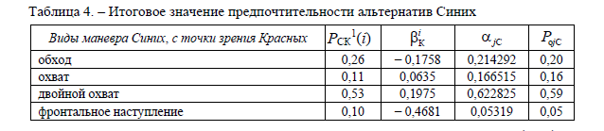

Table 4. - The final value of the preference for the BLU alternatives
The results obtained mean, for example, that the initially high (0.53), from the point
view of REDs, preference for Blue to choose the " double coverage " scenario by
the results of the influence of information of the second rank (decision-making for the enemy)
increased to 0.59. Therefore, this means that, given the awareness
which the Reds attribute to the Blues (regarding the likely actions of the Reds), for
It is rational for blue to use the " double coverage " strategy (in terms of
reasoning of Krasnykh). In the event that the initial preference is essential
differs from the final one obtained from the results of taking into account the influence of alternatives
higher rank - there is a logical contradiction. Thus, given
our awareness, the enemy is behaving illogically (illogically built
the distribution of the probabilities of the enemy's choice of a particular strategy). Either we
ask the wrong options for the enemy's behavior and their distribution
probabilities, or incorrectly set information that the enemy assumes
regarding our possible behavior. This situation may be due to
deliberate misleading by the enemy.
Determination of the influence of the first rank alternatives on the chosen alternatives
carried out in a similar manner. In this case, the calculation uses not the initial
probability P s , and the final probability P 0 j calculated at the previous step . Eventually
the following results were obtained (table 5):
Table 5. - Final preference for the choice of alternatives to Red

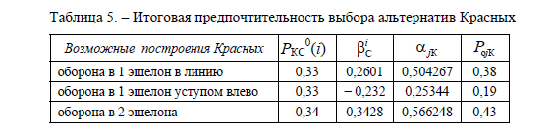

Conclusion
Thus, the initial distribution of probabilities of possible strategies of Red
{0.33, 0.33, 0.34} under the influence of information related to subsequent ranks
reflexive control, is transformed into distribution {0.38, 0.19, 0.43}. Eventually
Forms of CT maneuver , in terms of the Red P CK
1 ( i )
TO
i
β
C j
α
o C j
P
detour
0.26
- 0.1758
0.214292 0.20
coverage
0.11
0.0635
0.166515 0.16
double coverage
0.53
0.1975
0.622825 0.59
frontal attack
0.10
- 0.4681
0.05319
0.05
Possible formations of Red R KS
0 ( i )
C
i
β
K j
α
o K j
P
defense in 1 echelon in line
0.33
0.2601 0.504267 0.38
defense in 1 echelon ledge to the left
0.33
- 0.232 0.25344 0.19
defense in 2 echelons
0.34
0.3428 0.566248 0.43
(five)

Page 164
COLLECTION OF SCIENTIFIC ARTICLES OF THE MILITARY ACADEMY OF THE REPUBLIC OF BELARUS 32'2017
162
the most preferable for the Reds is the strategy of " defense in two echelons ",
most satisfying BLU's options. In real
life, this corresponds to a situation where initially we do not have any preferences
regarding the application of this or that option. We analyze how it can lead
the opponent himself, what decisions he will make based on what he knows
about Us. As a result, one's own preferred behaviors are inferred from
reasoning like: “Most likely, the enemy thinks of me like this ..., therefore, behave
will be like this ... then I will go like this ... ". As a result, thanks to the
the alleged awareness of the enemy about the actions of our side and information
worldview about the intended actions of the enemy, in the absence of initial
preferences regarding their own options, such alternatives will be chosen,
which maximally satisfy the entire spectrum of possible, from our point of view,
enemy behavior based on our beliefs about what he knows about us. On the
practice, these should be behavioral strategies with a well-organized preliminary
intelligence, the ability to recognize the enemy's intentions and the ability to
change. This approach can be extended to accounting information corresponding to
higher ranks of reflexive control.
List of references
1. Lobov, V. N. Military cunning / V. N. Lobov. - M .: Mosk. military history. about, 2001. -
358 s.
2. Lefebvre, V. A. Algebra of conflict / V. A. Lefebvre, G. L. Smolyan. - M .: Knowledge,
1968 .-- 62 p.
3. Lefebvre, V. A. Algebra of conscience / V. A. Lefebvre. - M .: Kogito-center, 2003 .-- 426 p.
4. Novikov, D. A. Reflexive games / D. A. Novikov, A. G. Chkhartishvili. -
M .: SINTEG, 2003 .-- 149 p.
5. Strategists of the Armed Forces of the USSR on the work of V. A. Lefebvre / V. V. Druzhin [and others] //
Reflexive processes and control. - 2006. - No. 1. - P. 54–57.
6. Thomas L. T. Reflexive control in Russia: theory and military applications /
L. T. Thomas // Reflexive processes and management. - 2002. - No. 1. - P. 71–89.
7. Ionov, M. D. Psychological aspects of enemy control in anta-
gonistic conflicts (reflexive control) / M.D. Ionov // Applied
ergonomics. Specialist. no. - 1994. - No. 1. - P. 44–45.
8. Leonenko, S. Reflexive control of the enemy / S. Leonenko // Arm. Sat. -
1995. - No. 8. - P. 28.
9. Chausov, F. S. Reflexive approach in management / F. S. Chau-
owls. - SPb., 2008 .-- 286 p.
10. From predictions to reflexive control / Z. H. Kramer [et al.] //
Reflexive processes and control. - 2003. - No. 2. - P. 35–52.
11. Buloichik, VM Military-applied problems of mathematical modeling.
Fundamentals of the theory of mathematical modeling of combat and combat operations / V.M.Buloichik. -
Minsk: VA RB, 2005 .-- 252 p.
12. Buloychik, VM Application of the principles of reflexive control for
a formalized description of the commander's mental activity when assessing the situation
and decision-making / V.M.Buloichik, E.V. Rulko // Vestn. military. acad. Rep. Belarus. -
2013. - No. 4. - P. 12–54.
______________________________
*Information about authors:
Rulko Evgeniy Viktorovich,
Buloychik Vasily Mikhailovich,
Gertsev Andrey Vladimirovich,
UO "Military Academy of the Republic of Belarus".
The article was received on 09.03.2017.

Список литературы
1. Лобов, В. Н. Военная хитрость / В. Н. Лобов. – М.: Моск. воен.-истор. о-во, 2001. –
358 с.
2. Лефевр, В. А. Алгебра конфликта / В. А. Лефевр, Г. Л. Смолян. – М.: Знание,
1968. – 62 с.
3. Лефевр, В. А. Алгебра совести / В. А. Лефевр. – М.: Когито-центр, 2003. – 426 с.
4. Новиков, Д. А. Рефлексивные игры / Д. А. Новиков, А. Г. Чхартишвили. –
М.: СИНТЕГ, 2003. – 149 с.
5. Стратеги Вооруженных Сил СССР о работах В. А. Лефевра / В. В. Дружин [и др.] //
Рефлексивные процессы и управление. – 2006. – № 1. – С. 54–57.
6. Томас, Л. Т. Рефлексивное управление в России: теория и военные приложения /
Л. Т. Томас // Рефлексивные процессы и управление. – 2002. – № 1. – С. 71–89.
7. Ионов, М. Д. Психологические аспекты управления противником в анта-
гонистических конфликтах (рефлексивное управление) / М. Д. Ионов // Прикладная
эргономика. Спец. вып. – 1994. – № 1. – С. 44–45.
8. Леоненко, С. Рефлексивное управление противником / С. Леоненко // Арм. сб. –
1995. – № 8. – С. 28.
9. Чаусов, Ф. С. Рефлексивный подход в управленческой деятельности / Ф. С. Чау-
сов. – СПб., 2008. – 286 с.
10. От предсказаний к рефлексивному управлению / З. Х. Крамер [и др.] //
Рефлексивные процессы и управление. – 2003. – № 2. – С. 35–52.
11. Булойчик, В. М. Военно-прикладные вопросы математического моделирования.
Основы теории математического моделирования боя и боевых действий / В. М. Булойчик. –
Минск: ВА РБ, 2005. – 252 с.
12. Булойчик, В. М. Применение принципов рефлексивного управления для
формализованного описания мыслительной деятельности командира при оценке обстановки
и принятии решения / В. М. Булойчик, Е. В. Рулько // Вестн. воен. акад. Респ. Беларусь. –
2013. – № 4. – С. 12–54.
______________________________
*Сведения об авторах:
Рулько Евгений Викторович,
Булойчик Василий Михайлович,
Герцев Андрей Владимирович,
УО «Военная академия Республики Беларусь».
Статья поступила в редакцию 09.03.2017 г.
Related to area in paper where zero is entered for not knowing what behavior strategy to follow:

AUTHCR: Novikov, P. P.; Parfenova, L. P.; Dankin, D. r:.; Kartashev, D. N.
S!.O: none
TITIL: Algorithns for programs of bhhavior u-nder conditions of minimal infor.ation
about the environment
SOUhCE; Vsesosjznaya konferantslya po neonokibernetlke, 3d, Rostov-on-Don, 1967.
Problemy neyrokibernetiki (Probicms of ncurocybernotics); referaty dokladov
konferentsii. Rostov-on-Don, Izd-vo Rostovskogo univ., 1967, 104-105
TOPIC TAGS: behavior pattern, algorithm, mathematic model, computer simulation,
computer memory
ABSTRACT: Two algorithms for behavior forriation under conditions of minimal
information about the environment were developed in experiments with man and animals.
The experimental environment was a discrete branching process with nodes of the "and"
or "or" typos, and with "prohibition" nodes. Three large functional blocks wore
distinguished in the algorithms: planning of search, of learning, and of control.
The program memory consists of four seztions: "imprersion," short term memory, list
long term memory, and high speed long term memory, which are distinguished by
designation, volume, method, and access zpeed. The complex structure of the memory
provides lability of the program during processing of input information. The
algorithms were simulated on a digital computer and compared with the behavior of the
living system, and the results of simulation and limits of application of these
algorithms are given.
243.

BIONICS AND BIOCYBERNETICS
Alan Campbell
Library of Congress
Washington. D. C.
5 December 1968
[Need to go through entire book and find references to research from 60s.]

----------------------------------------

Automation of combat control in the troops of the P ON
- Jan 1988
- Yu V Glebov
- VA Abramov
Glebov Yu.V., Abramov V.A. Automation of combat control in the troops of the P ON. -X .: VIRTA P ON, 1988.230 p.
https://www.researchgate.net/publication/329721824_ANALIZ_METODOV_FORMALIZACII_PROCESSA_UPRAVLENIA_INFORMACIONNYM_POTOKOM_SOOBSENIJ_OB_OBEKTAH_NABLUDENIA_V_AVTOMATIZIROVANNOJ_SISTEME_UPRAVLENIA

--------------------------------------------

ML Tsetlin 1950s was the f= irst to raise the question of the possibility of modeling complex forms of = behavior using the simplest technical means. These ideas served as the beginning of the creation of the theo= ry of collective behavior of technical systems, much ahead of similar studi= es in other countries [19]. (Pospolev, computing history)

In mid-1957, the author of the article clearly define= s the directions of strategic research in the field of computer science. <= font style=3D"vertical-align: inherit;">According to V.M. Glushkov, the bas= is of the progress in the development of computers should be the theory of = their operation, the development of methods for automating the design of co= mputers and the development of methods for automating programming. <= /font>He emphasizes the important role of resea= rch in the field of the theory of algorithms and the theory of finite deter= ministic and stochastic automata, the fundamental importance of developing = methods of symbolic transformations on a computer (analytical transformatio= ns, theorem proving, machine translation), notes the central role played by= the problem of program optimization (especially for control machines ), an= d also points to the reverse influence of the development of computers on f= urther work in the field of computational mathematics. (pospolev, history)

Soon, books by Russian specialists appeare= d [22-25].=20 In 1958, IA Poletaev's "Signal"= was released. As already mention= ed, all the authors of the first Russian books on cybernetics were military= men, worked in educational institutions that trained personnel for the Min= istry of Defense. The Zhukovsky a= nd Dzerzhinsky Academies in Moscow, the Mozhaisky Academy in Leningrad, the= Kharkov Higher Aviation Technical School and the Kiev Higher Radio Enginee= ring School were the first military educational institutions where the teac= hing of cybernetics became compulsory.

In the mid-1950s, a seminar on the theory = of automata began at the Physics Faculty of Moscow State University [40], w= hose permanent leader until his premature death was ML Tsetlin. This seminar became the center around which,= over time, a national school in the field of collective behavior of automa= ta developed. Models of this type= had a pronounced cybernetic character, and their study was unthinkable wit= hout special methods of computer modeling. <= /a>Not only physicists, but also physiologists, programmers, mathema= ticians took an active part in the seminar. = An extraordinary and multifaceted personality of the leader [41]= attracted wide circles of the scientific community to participate in the s= eminar on the behavior of automata. The topic of the seminar linked the problems of logical analysis and syn= thesis of circuits with the problems of machine modeling and models of beha= vior of living systems.

The model theory of thinking, deve= loped in the works of V.N. Pushkin, served as the basis for the development= of a method for situational control of large systems. This method, which emerged in the second half of the = 60s [85], largely anticipated the technology of solving problems in knowled= ge-based systems (such a technology emerged in research on artificial intel= ligence only in the mid-70s in expert systems). With the help of the method of situational control, it was p= ossible to solve a number of practical problems, and its use continues to t= his day [86, 87]. The importance = of work on situational management in our country is very great. A large number of specialists engaged in the= development of this approach and its application to solve practical proble= ms (over the decade of activity of the "situational movement" in 1967-77, a= bout two dozen conferences, symposia and schools were held, through which s= everal hundred specialists passed), turned out to be prepared for immediate= transition to artificial intelligence technologies as soon as they appeare= d in the early 70s.=20

- Since the second half of the 60s, = cybernetic control models and methods for solving complex problems on compu= ters began to be actively introduced into real control systems of various l= evels. This initiative was active= ly supported by the government in the form of significant funding for gover= nment programs to create automatic management systems for enterprises, indu= stries, regions and national systems. Programs for the development of networks for the transmission and proc= essing of information, which were supposed to cover the entire country, wer= e linked to the global ideological program of building a communist society.= =20 These "Napoleonic" plans were= not supported by the necessary technical base and were doomed to failure. = But, oddly enough, there was stil= l some benefit from this movement. The training of specialists in automated co= ntrol systems of various profiles was organized, which later made it possib= le to make computer science a mass profession. And, finally, new results were obtained in the field of infor= matics and management in large technical, economic, organizational and soci= al systems, which entered the scientific circulation [106].=20
- Work in the field of= image processing has always lagged somewhat behind the leading front in th= e West in our country, which, in particular, can be explained by the weakne= ss of the technical base for such work in our country. Against this background, the cycle of studies carried= out at the Institute for Information Transmission Problems of the Academy = of Sciences of the USSR under the leadership of VS Fain В. С. Файна [107] stands apart.= The team headed by him for the f= irst time in world practice managed to solve the problem of computer modeli= ng of dynamic processes (in particular, aging and rejuvenation processes) o= ccurring in biological objects. I= n a sense, these achievements have not been surpassed in world informatics = so far.=20

School = M. L. Tsetlin - M. M. Bongard. Mathematicians, programmers, physiolog= ists, engineers and physicists have united around these two bright and dist= inctive leaders. The main circle = of interests of the school participants was concentrated around the problem= s of modeling in biology, physiology, medicine and ethology. = The achievements of this school in the field = of inductive formation of concepts, models of vision, patterns of tissue gr= owth and collective behavior are largely unattainable for Western science t= o this day.

